Presents
The Missing Food Mystery
Student Data Log
Simple actions you take can reduce food waste.
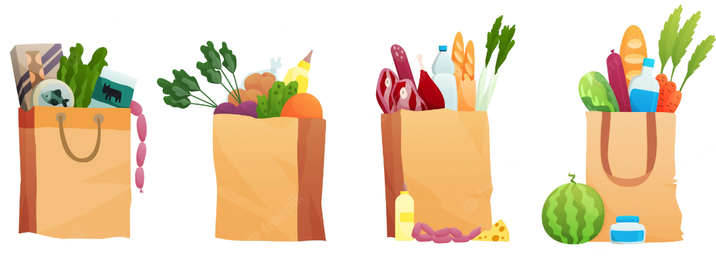
This Workshop was funded in part by a WRRED grant from the Department of Ecology

Activity 1a: My Favorite Foods

Activity 1b: Where do you think missing food goes?
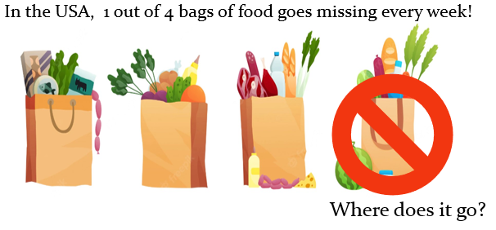

I think missing food goes____________________________________
________________________________________________________
________________________________________________________
________________________________________________________.

Activity 1c: Warming up our Investigator senses

What did you see? ______________________________________________
What did you hear? _____________________________________________
What did you smell?_____________________________________________

Activity 1d: Copy the list of 7 things scientists do to investigate an issue.
- ________________________________________________
- ________________________________________________
- ________________________________________________
- ________________________________________________
- ________________________________________________
- ________________________________________________
- ________________________________________________

Activity 1e: Why is missing food a problem? Why does it matter?
I think missing food is a problem because ________________________________________________________________________________________________________________________________________________________________________________________________________________________________ ________________________________________________________________________________________________________________
Missing food matters because ________________________________________________________________________________________________________________________________________________________________________________________________________________________________________________________________________________________________________________________________________________
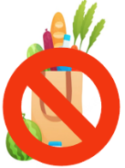
Activity 2a: Where in the world are most bananas grown?
Circle the area on the world map where the most bananas are grown.
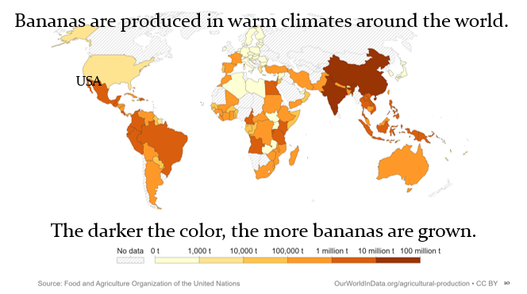

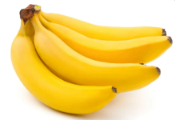

Activity 2b: The Life Cycle of Bananas
- Cut apart the pictures of the resources used to grow, transport, and sell bananas.
- Put the pictures in the order that they happen.
- Tape or glue them on the next page (page 4) in your MYSTERY DATA LOG
- Add icons of resources that are needed for each step in the life cycle.

Activity 2b: The Life Cycle of Bananas Paste or tape the life cycle images on this page.

Activity 2c: Why do you think food is wasted?
I think food is wasted because ________________________________________________________________________________________________________________________________________________________________________________________________________________________________

Activity 3a: Why is food wasted?
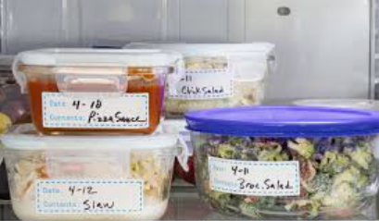
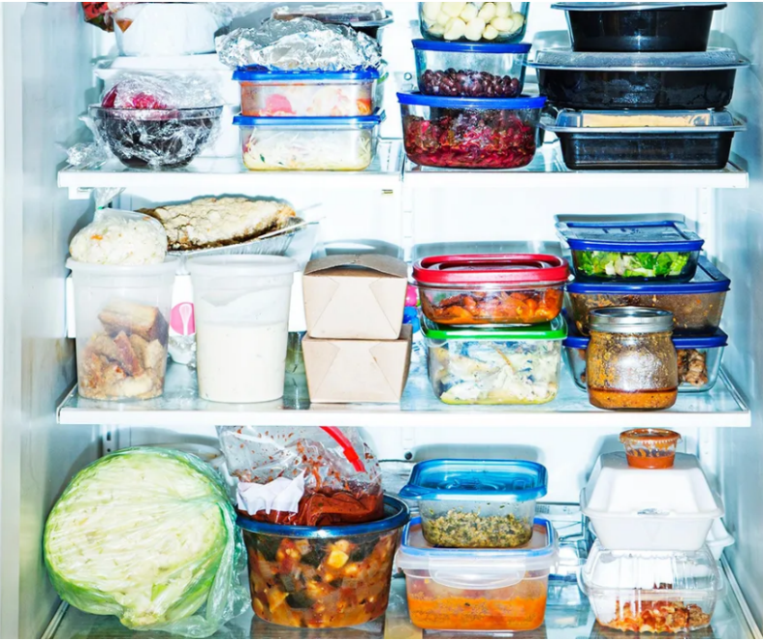
Put a circle around food not stored properly. Put a star on food stored properly.
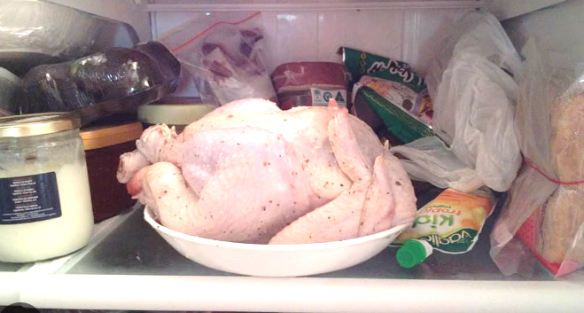

Activity 3b: Where is away?
Write one or two ideas about where food goes when it is thrown “away.”
________________________________________________________________________________________________________________________________________________________________________________________________________________________________________________________________________________________________________________________________________________

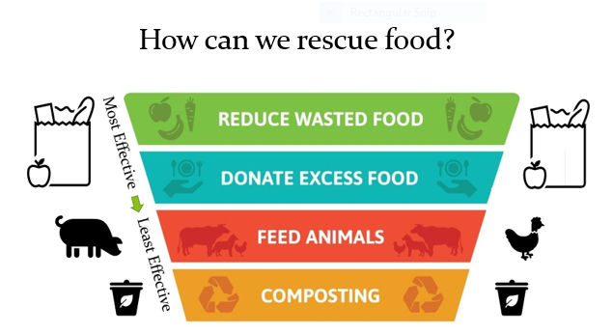
Activity 5a: Group Activity – Ideas for solutions.
Your group will have a couple of minutes to talk about how you could help to prevent food waste. Take a bit of time to think about actions you could take and when you’re finished, we’ll hear ideas from each group.
Put your ideas here.
________________________________________________________________________________________________________________________________________________________________________________________________________________________________________________________________________________________________________________________________________________________________________________________________________________________________________________________________________________________________________________________________________________________________________________
Activity 5b: Investigate wasted food at home.
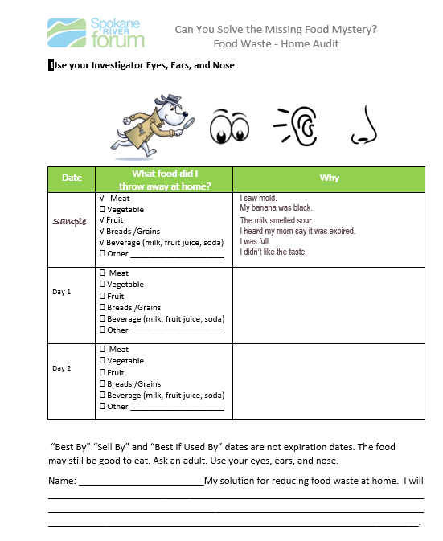
Use this waste audit data sheet.
Activity 5c: Investigate wasted food at school.
Use this waste audit data sheet.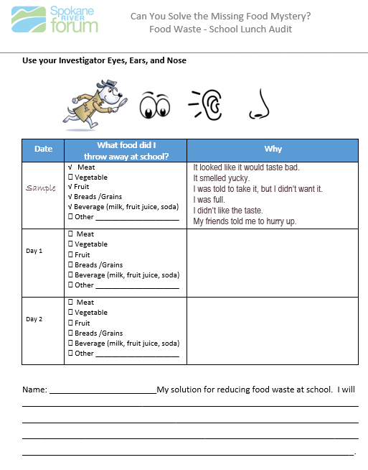
Activity 6: How can we inspire people to reduce food waste?
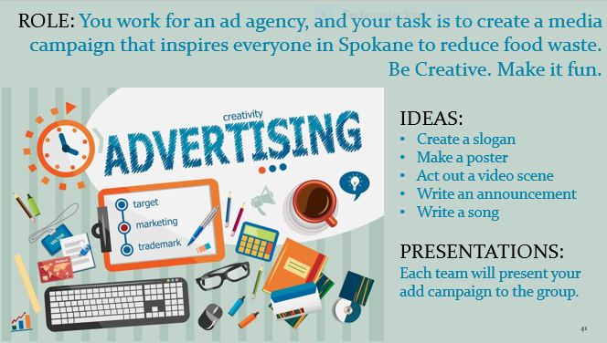

___________________________________________________________________________________________________________________________________________________________________________________________________________________________________________________________________________________________________________________________________________________________________________________________________________________________________________________________________________________________________________________________________________________________________________________________________________________________________________________________________________________________________________________________________________________________________________________________________________________________________________________________________________________________________________________________________________________________________________________________________________________________________________________________________________________________________________________________________________________________________________________
Vocabulary

compost (v.) recycling natural waste like food scraps or leaves to make fertilizer that helps plants grow.

donate: (v.) to make a gift of, to contribute to a public or charitable cause

energy: (n.) Power from resources, like water, sunlight, gas, electricity. This power can be used for many things, such as providing light and heat or to help machines work.

environment: (n.) The natural world. The living things on Earth and the non-living things they need to live, like water, soil, and sunlight. Environment can be all of the living and non-living things in a particular area like Spokane, or in a field, forest, or river.

expire: (v.) to come to an end

expiration date: (n.) the date after which a product (such as food or medicine) should not be sold or used because of an expected decline in quality or effectiveness.

hierarchy: (n.) a graded or ranked series

ingredients: (n.) items used to make food.

investigate: (v.) to observe or study by close examination and systematic inquiry

landfill: (n.) a dump, a place where garbage is taken and buried after people throw it away.

methane: (n.) a colorless, odorless, flammable gas that is a product of biological decomposition of organic matter. Methane is harmful to the environment.

mystery: (n.) something not understood

observe: to watch carefully with attention to details or behavior

preferred: (v.) liked better or best
recover: (v.) to get back
reduce: (v.) to make smaller in size, amount, or number
resources: (n.) Materials, like water or sunlight, which people use in different ways. For example, people who work at clothing factories use electricity and fabric, like cotton, to make clothes.

waste: (n./v.) Trash. Waste can also mean throwing away food or other resources that are still usable.

Waste to Energy Facility: (n.) A place in Spokane where trash is collected and burned.
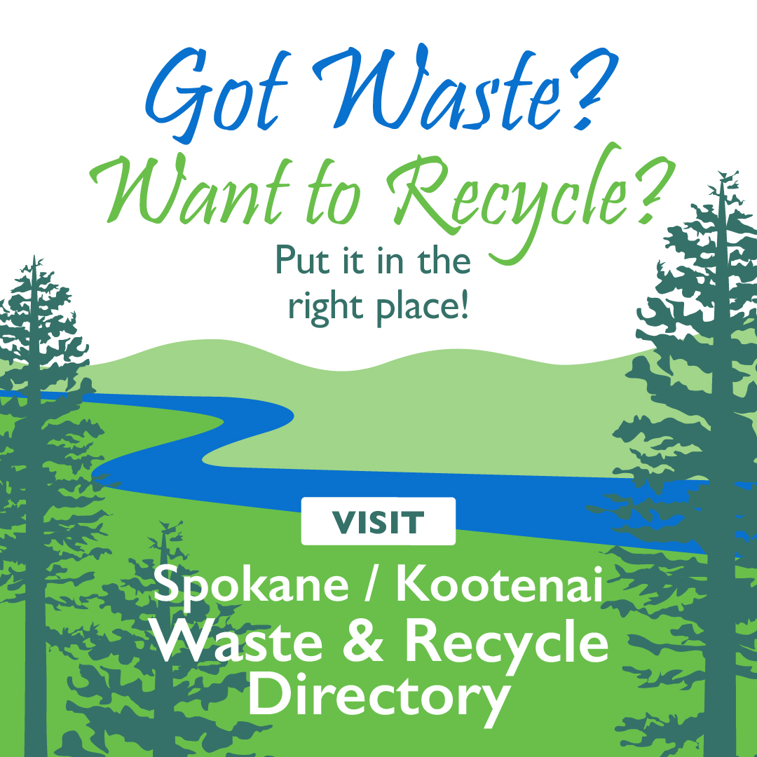

www.SpokaneWasteDirectory.org
www.KootenaiWasteDirectory.org

